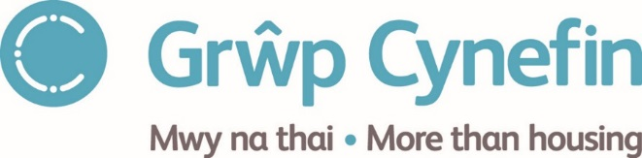
Board Member Application Form
(The content of this form will be treated confidentially by the Recruitment Panel)

PERSONAL INFORMATION

Name
Address
Phone number | Home: | Mobile:
E-mail address

EDUCATION AND QUALIFICATIONS

Subject | College / University | Qualification | Year

EMPLOYMENT HISTORY (Explain any gaps please)

Date

MEMBERSHIP OF ANY PROFESSIONAL ORGANISATIONS

Date

TELL US WHY YOU’D LIKE TO BECOME A BOARD MEMBER, AND WHAT SKILLS AND EXPERIENCE YOU HAVE TO OFFER

DETAILS OF ANY Criminal convictions appart from any Expired convictions (as defined by the rehabilitation OF OFFENDERS act 1974)

NAME, ADDRESS, AND PHONE NUMBER OF TWO REFEREES
(We won’t contact the referee without seeking your consent)
1. | 2.

PLEASE NOTE IF YOU ARE RELATED TO ANY CURRENT MEMBER OF THE BOARD / MEMBER OF STAFF

The application form should be returned to eleri.jones@grwpcynefin.org by 12 noon 22 July 2022.

THANK YOU VERY MUCH.

